

SQl aSSIGNMENT

By Sonia Shah



January 21, 2024

Contents

**Task 13**

**Task 23**

**Task 34**

**Task 44**

**Task 55**

**Task 65**

**Task 76**

**Task 86**

**Task 97**

**Task 107**

**Task 118**

**Task 128**

#Task 1 - Using count, get the number of cities in the USA​

SELECT count(*) from city where CountryCode = 'USA';

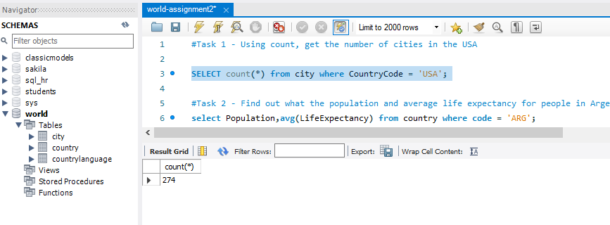

#Task 2 - Find out what the population and average life expectancy for people in Argentina (ARG) is.

select Population,avg(LifeExpectancy) from country where code = 'ARG';

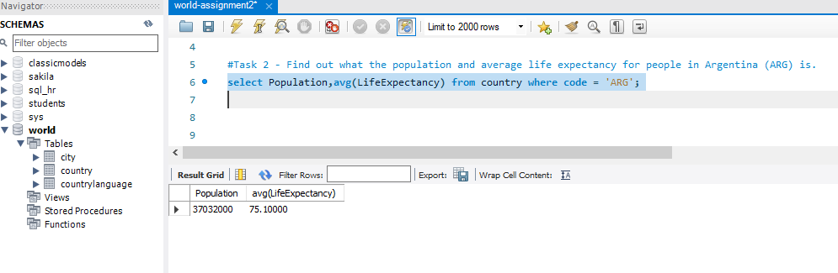

#Task 3 - Using ORDER BY, LIMIT, what country has the highest life expectancy?​

select * from country order by LifeExpectancy desc limit 0,1;

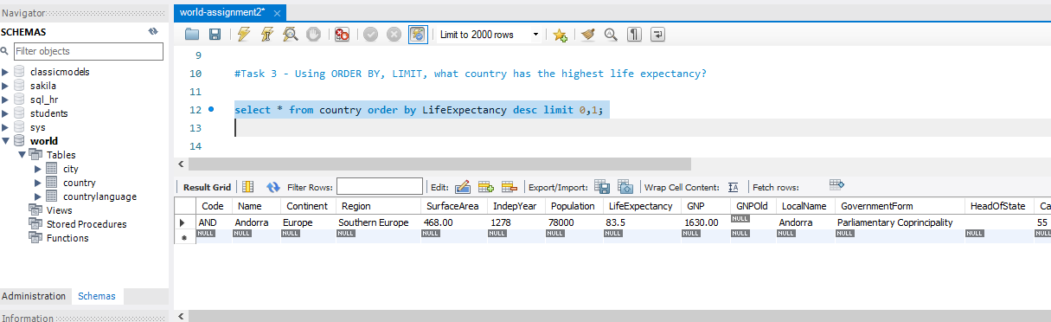

#Task 4 - Select 25 cities around the world that start with the letter 'F' in a single SQL query.​

SELECT * from city where name like 'F%' limit 0,25;

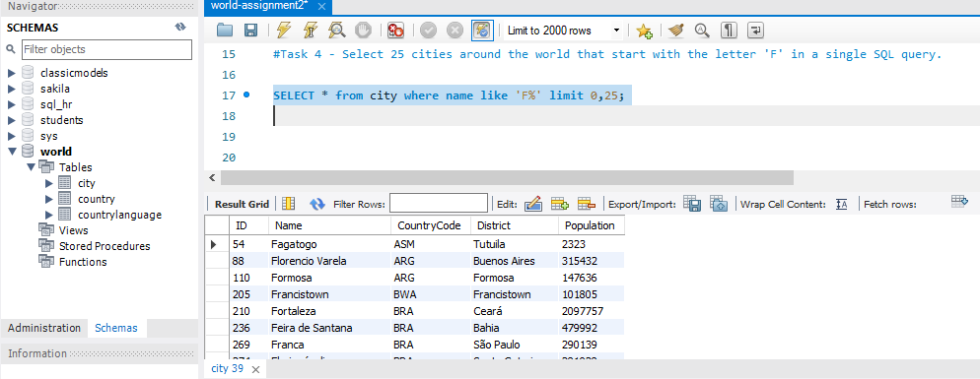

#Task 5 - Create a SQL statement to display columns Id, Name, Population from the city table and limit results to first 10 rows only.​

SELECT ID,Name,population from city order by id limit 0,10;

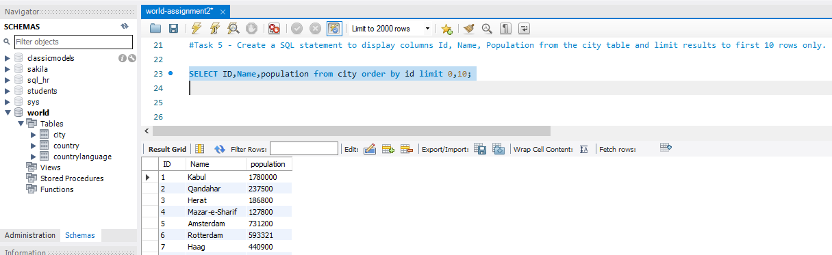

#Task 6 - Create a SQL statement to find only those cities from city table whose population is larger than 2000000.​

SELECT * FROM city where Population > 2000000;

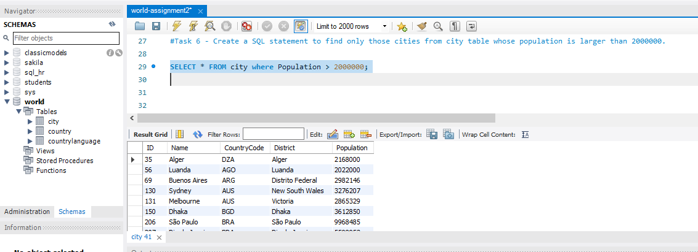

#Task 7 - Create a SQL statement to find all city names from city table whose name begins with “Be” prefix.​

SELECT * FROM city where name like 'Be%';

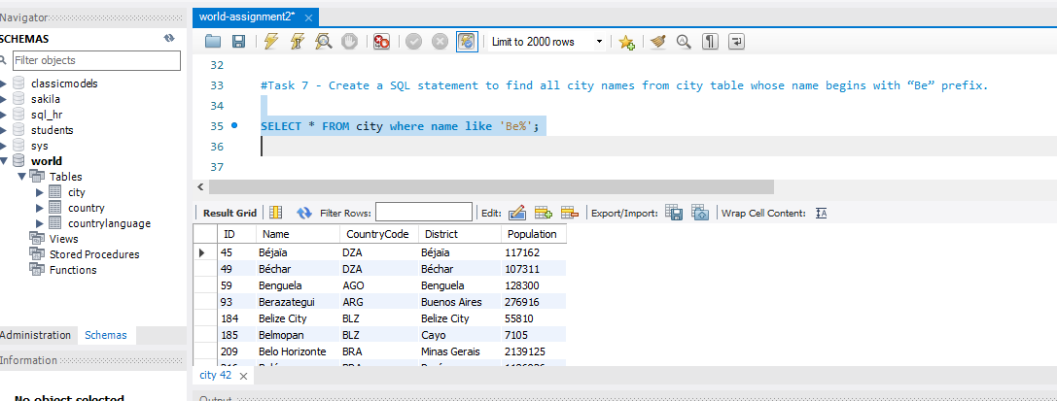

#Task 8 - Create a SQL statement to find only those cities from city table whose population is between 500000-1000000.​

SELECT * FROM city where Population between 500000 and 1000000;

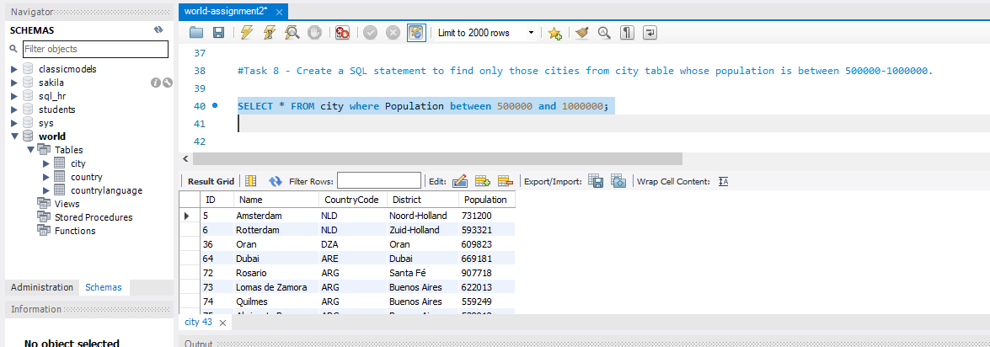

#Task 9 - Create a SQL statement to find a city with the lowest population in the city table.​

SELECT population,name,CountryCode from city order by population asc limit 0,1;

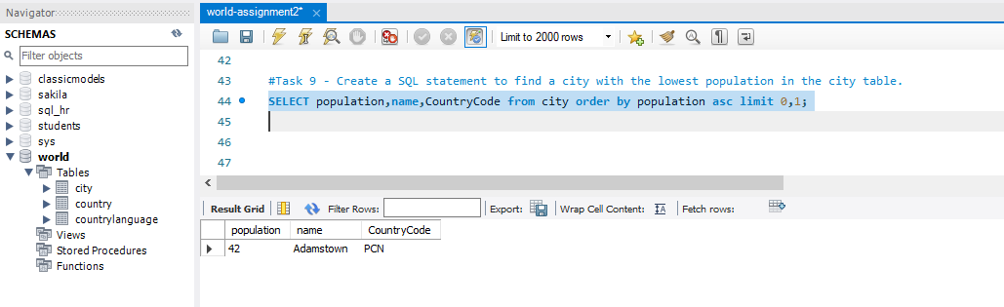

#Task 10 - Create a SQL statement to find the capital of Spain (ESP).​

select c.name , cc.Name from country c inner join city cc on c.Code = cc.CountryCode where c.Code = 'ESP' and c.Capital = 653 group by c.name,CC.NAME limit 0,1;

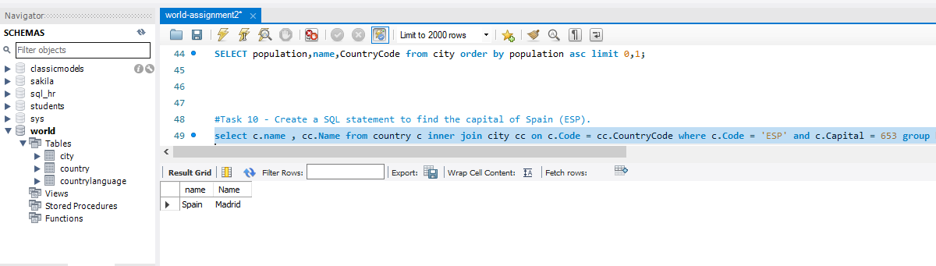

#Task 11 - Create a SQL statement to list all the languages spoken in the Caribbean region.​

select distinct(language) from countrylanguage cl inner join country c on cl.CountryCode = c.Code where region = "Caribbean";

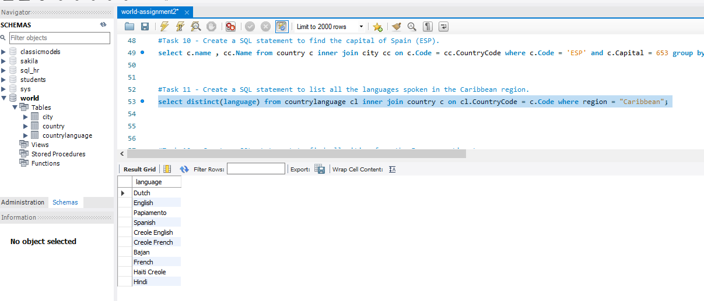

#Task 12 - Create a SQL statement to find all cities from the Europe continent.

SELECT c.name FROM City c inner join country cc on c.CountryCode = cc.Code where Continent = "Europe";

